

Republic of the Philippines
Department of Education
Cordillera Administrative Region
SCHOOLS DIVISION OFFICE
Bangued – 2800

Sept. 14, 2016

DIVISION MEMORANDUM
No. 145 s. 2016

DIVISION VALUES EDUCATION RIPPLE 2016

TO: ALL PUBLIC SCHOOLS DISTRICT SUPERVISORS (PSDS)
ALL PUBLIC & PRIVATE ELEMENTARY & SECONDARY SCHOOL HEADS

1. The DIVISION VALUES EDUCATION RIPPLE 2016 shall be conducted at Bangued West Central School and DepEd- Division Office on Oct. 17, 2016 in consonance with the Annual National Convention of the Pambansang Samahan Para Sa Edukasyon sa Pagpapahalaga (PSEP, Inc.) to be held on Dec. 2-4, 2016 at Crown Legacy Hotel, Baguio City with the theme: “Ang Kabataang Pilipino sa Gitna ng Globalisasyon”.

2. The activity aims to:
a) Deepen educator’s commitment to their responsibilities in carrying out various
activities in EsP in leading the youth amidst globalization
b) Showcase Filipino positive values through student’s creative participation in various contests and activities

3. Contest categories are the following:

Elementary Secondary
- On-the-Spot Poster Making a. On-the-Spot Poster Making
- Sayawit b. Sayawit
- Tagis Talino c. Tagis Talino

4. Participants to the said contest are the winners (Champion) from the different secondary schools and different district winners (champions from the 28 districts). Private schools are encouraged to send their school champion too.

5. A minimal contest fee of P 30.00 per contestant and P 50.00 per coach shall be charged from participants to defray operational expenses for the said activity. This amount shall be charged against local funds (MOOE) or other available funds. A Pre-registration period any day from Oct. 10-14, 2016 at the Schools Division Office (SDO-CID Office) is encouraged to maximize time for the contest proper on the 17th.

6. Enclosed is a copy of the guidelines and criteria for judging.

7. Immediate and wide dissemination of this memorandum is enjoined.

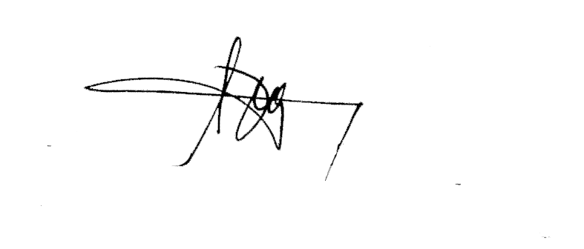

RONALD B. CASTILLO, CESO VI
Schools Division Superintendent

Inclosure No. 1 to Division Memorandum No. 145 s. 2016

Guidelines & Criteria in the conduct of the Division Values Education Ripple
- There shall be only one (1) representative from each district (28 districts) in the elementary for each category and one (1) representative per school in the secondary in every category.
- No pupil/student shall compete in two or more categories to give chance for others to compete.

Rules for the Tagis Talino (Quiz-elementary & secondary)
- The team shall be composed of three (3) members only.
- The team will compete in the EASY (1pt.) AVERAGE (3pts.) and DIFFICULT (5pts.).
- There will be ten questions per category in the Secondary and 5 questions per category in the elementary that relate to the contents of Values Education/EsP (G7-10 and Edukasyon sa Pagpapakatao/Character Education (grades 5 & 6) respectively.
- The Quizmaster will read the questions twice and the team will be given 15 seconds to write their answer on their board/magic slate then wait for the Quiz Master’s signal to raise their answers. Scorers will check and tally scores on the scoreboard.
- The three teams with the highest scores will be declared as winners. (champion, 1st Runner Up, 2nd Runner Up)
- In case of a tie, the Quiz master will ask another three questions. The team/s with the higher/est score will automatically be declared as the winner.

RULES FOR THE SAYAWIT(ELEMENTARY & SECONDARY)
- Sayawit must be relevant to the PSEP convention theme.
- Presentation time must not exceed 10 minutes including entrance & exit and other preparations for the stage.
- Number of participants must be from 7-10 members. (singers and dancers, excluding technical assistants, who are singing and dancing at the same time)
- Contestants must use props and other stage sets.
- Live accompaniment is required and no lip-sinchs.
- Costumes must be appropriate to the movements.

CRITERIA FOR JUDGING (SAYAWIT)
- Concept relevance to the theme - 30%
- Choreography and staging - 25%
- Musicality - 25%
- Props, costumes and audio-visual effects - 10%
- Overall staging impact - 10%
TOTAL 100%

RULES FOR THE ON-THE-SPOT POSTER MAKING (ELEMENTARY & SECONDARY)

- Contestants are advised to bring their own materials. (1/4 illustration board, pencil and pastel/craypas) The elementary contestants may be represented by one who is enrolled in any level from Grades 4-6 while secondary contestants may be represented by one who is enrolled in any level from Grades 7-10.
- Contestants are given 3 hours time allotment to finish their work.
- Lettering and borders are not allowed as part of the presentation.

CRITERIA FOR JUDGING (ON-THE-SPOT POSTER MAKING)

- Concept relevance to the theme - 30%
- Creativity - 25%
- Originality - 25 %
- Visual Impact - 20%
TOTAL 100%

Note: Three copies of the lyrics of the songs in the Sayawit competition shall be submitted during the pre-registration.

