Republic of the Philippines

DEPARTMENT OF EDUCATION
Cordillera Administrative Region

SCHOOLS DIVISION OF ABRA

September 13, 2016

DIVISION MEMEORANDUM
No. 140_ _S., 2016

TO: Heads, Public Elementary and Secondary Schools
Division Office Personnel
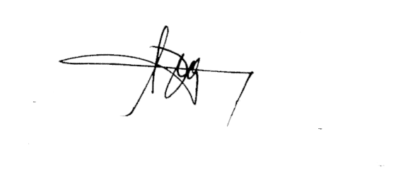

From: RONALD B. CASTILLO, CESO VI
Schools Division Superintendent

Subject: Conduct of Synchronized National Clean Up
__________________________________________________________________________________
- Pursuant to Regional Memorandum no. 251, series 2016, re: Implementation of the Clean 500 Program “ Bayan ko, Linis Ko” under the 5 Point Agenda on the Environment for the first 100 days of President Rodrigo R. Duterte, a Synchronized National Clean Up will be undertaken on September 17, 2016 from 8:00 to 12:00 in the morning. All Line agencies and Local Government Units are required to participate. Relative to this, all schools through their Youth for Environment in Schools Organization (YES-O), Supreme Student Government (SSG), and other school organizations and all Division Office Personnel are enjoined to actively participate in this program.
- Participating schools must first register in the official Facebook page of the Basura Patrol Program of DENR at https://www.facebook.com./denr.emb.swmd/app/684336108254110. A school, considered as one team, must fill up necessary information in the registration form provided online. Team leaders can be either school head or the club adviser.
- The team leader or assigned documenter must also take pictures “ Before, During, and After activities. The data on waste collected must be uploaded on the Facebook page mentioned above.
- The collected biodegradables waste must be composted and the recyclables will be processed or stored at the school or barangay Material Recovery Facility (MRF).
- Aside from submitting data through Facebook, same data must be recorded by completing the Registration Form (Enclosure 1) and Reporting Form (Enclosure 2). A copy of each form must be submitted to the host barangay of the school and to the Social Mobilization Unit of the Schools Division Office.
- Compensatory Overtime Credit shall be granted to all teaching and non-teaching staff who will render service during said activity.
- Expenses incurred shall be charged against local funds subject to the usual accounting and auditing rules and regulations.
- Immediate dissemination and compliance to this Memorandum is enjoined.

