August 30, 2016

**Division Memorandum**

**No. 125, s. 2016**

**“RELEASE OF CERTIFICATES OF RATINGS, CHECKING OF ALS PASSERS NAMES AND CONDUCT OF A&E TEST 2015 RESULT EVALUATION USING**

**D.O. TEMPLATE,”**

**TO :** Chief CID, EPS I-ALS, EPS II-ALS,

District Supervisors,

ALS Implementers and All Others Concerned

1. As per DepEDMemorandum, DM-CI-2016-00111 dated July 22, 2016 the test results / Certificate of Ratings (CORs) of the 2015 Accreditation and Equivalency Test conducted last April 17, 2016 is now ready for release.

2. The original copy of the Certificate of Rating must be released directly to the test taker.Due to this premise; ALS IMPLEMENTORS are hereby advised to prepare acknowledgement receipt duly accomplished by the test takers for this purpose and furnished the division office with said acknowledgement form as reference file on or before September 30, 2016. Attached is the acknowledgement receipt template.

3. On misspelled names in the Certificate of Ratings,Original copy of the COR for correction together with the photocopy of the authenticated birth certificate and the copy of the upper portion of the Registration Form must be forwarded to the Division Office ALS Section on or before September 9, 2016.Attached is the misspelled names correction template.

4. Further, on the concerted quest of all ALS implementers for continuous improvement with regards to A&E test performance, all ALS implementers are hereby advised to conduct massive evaluation on the A&E Test Result as to where, what, and how to improve each learner performance based on the Certificates of Ratings. Reports must be submitted at the ALS Division Office on or before September 9, 2016. Attached is the A&E Evaluation Template.

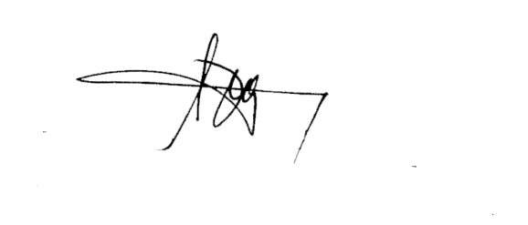5. Immediate compliance of and dissemination to all concerned is enjoined.

**RONALD B. CASTILLO, CESO VI**

Schools Division Superintendent

Enclosure 1 to DepED Division Memo. 125, s. 2016

**ACKNOWLEDGEMENT RECEIPT**

______________

(Date)

**TO WHOM IT MAY CONCERN:**

We/ I certify that we have/had received our/my original Certificate of Rating (April 17, 2016 A&E Test Result) from the DepED ALS Division Office in good condition.

____________

(District)

|  |  |  |  |
| --- | --- | --- | --- |
| **Names** | **Level** | **Status** | **Signature** |
|  |  |  |  |
|  |  |  |  |
|  |  |  |  |
|  |  |  |  |
|  |  |  |  |
|  |  |  |  |
|  |  |  |  |
|  |  |  |  |
|  |  |  |  |
|  |  |  |  |
|  |  |  |  |
|  |  |  |  |
|  |  |  |  |
|  |  |  |  |
|  |  |  |  |
|  |  |  |  |
|  |  |  |  |
|  |  |  |  |
|  |  |  |  |
|  |  |  |  |
|  |  |  |  |

Prepared by: Noted by:

______________________ _____________________

ALS Implementer PSDS

Enclosure 2 to DepED Division Memo.125, s. 2016

**REPORT ON MISSPELED NAMES ON THE COR**

|  |  |  |
| --- | --- | --- |
| **MISPELLED NAME (From)** | **CORRECT NAME (To)** | **REMARKS**  **(Attachment/Reference)**  **Ex. authenticated birth certificate and the copy of the upper portion of the Registration Form** |
|  |  |  |
|  |  |  |
|  |  |  |
|  |  |  |
|  |  |  |

Prepared and submitted by:

_______________________________

(ALS Implementer)

Noted by:

___________________________

(District In-Charge/PSDS)