

Republic of the Philippines
DEPARTMENT OF EDUCATION
Cordillera Administrative Region
SCHOOLS DIVISION OFFICE OF ABRA
Bangued, Abra2

August 30, 2016

Division Memorandum
No. ____186___ s. 2016

Selected Players for the Inter-agency Sports activities

TO: Elementary /Secondary School Heads
Unit heads concerns

- In view of our participation in the inter-agency Sports activities sponsored by the provincial Government of Abra under the leadership of Governor Ma. Jocelyn Valera Bernos, the following athletes were selected to represent SDO-Abra in the different sports disciplines:
BASKETBALL
Name of Athlete |  | School/Office
1 | Leonard Ballena | Tayum CS
2 | Laurence Barbosa | Christina B. Gonzales Memorial National High School
3 | Bonie Bernal | SDO
4 | Marlou Borja | SDO
5 | Darwin Bringas | SDO
6 | Marino Taclawan | Pulot NHS
7 | Jomar Brub | Naguilan ES
8 | Ray-ann Buenafe | RENHS
9 | Jonathan Laureta | NANHS
10 | Jun-Jun Cortel | Pilar Rural HS
11 | Ian Cabutaje | SDO
12 | Edsel Managbao | Lagangilang CS
13 | Gualberto Pabillano | CBGMNHS
14 | Rex pabillano | SDO
15 | Darwin Gabadan | Bilabila ES
Coach: Rolando Gasmen |  | AHS
Assist. Coach: Celso Tacanay |  | SDO
Volleyball (Men)
Name of Athlete |  | School/Office
1 | Richard Viado | NANSHS
2 | Arvin Ta-a | NANHS
3 | Rosel Polis | Calaba ES
4 | Sanny Borja | Agtangao ES
5 | Arnel Borillo | SDO
6 | Henry Barbon | Lam-ag ES
7 | Nathaniel Andaya | Pulot NHS
8 | Olly Joy Sulian | Danglas ES
9 | Julio Galera | Bangued West CS
10 | Rhap Kevin Ta-a | MYBBMHS
11 | Argie Ponio | San Quintin CS
12 | Marino Taklawan | Pulot NHS
13 | Esteban Tamayo | Liguis ES
14 | Lester viernes | Lusong NHS
Volleyball (Women)
Name of Athlete |  | School/Office
1 | Laila Galvan | Bonglo PS
2 | Christine Poblete | Ba-ay ES
3 | Maureen Barbosa | AHS
4 | Matilde Ci-o | Pulot ES
5 | Glenda Domingo | Pulot ES
6 | Teresa Cabcaban | AHS
7 | Meldie Damian | SDO
8 | Rhoda Asencio | SDO
9 | Margie Labanen | Lagayan CS
10 | Darell Ann Bartolina | Pulot NHS
11 | Carol Balaoro | Alimosgan ES
12 | Ramelita Galera | Paganao ES
Badminton (Men)
Name of Athlete |  | School/Office
1 | Jacinto Bose | La Paz CS
2 | Mijurodel Rifareal | CBGMHS
3 | Jumar Brub | San Gregorio ES
4 | Oliver Caliwag | AHS
Baminton ( Women)
Name of Athlete |  | School/Office
1 | Mia Jane Viernes | Luba CS
2 | Arcelie Beleno
Lawn Tennis
1 | Pedro Villastiqui Jr | MYBBMHS
2 | Salacnib Dangalan | Bolbolo NHS

- The selected athletes are required to submit certification from their respective school heads that their respective classes will be manned properly in compliance with “engaged-time on task” and that their school heads permit them to attend their games as scheduled.

- The Schedule of games were as follows:

- Basketball: 3:00 PM, ,Wednesday and Friday

- Volleyball (Men and Women): 3:00 PM, Tuesday and Thursday

- Badminton and Lawn Tennis: Every Saturday

- Uniforms and Snacks be shouldered by SDO funds while transportation of athletes will be charge
to local funds subject to usual auditing rules and regulations.

- Selected athletes will have their practice at Bangued west Central School on September 1 and 2,
2016.
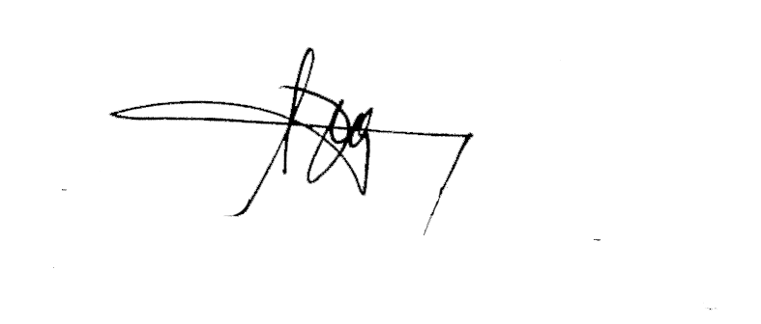
- Wide dissemination and immediate compliance to this memorandum is desired.

RONALD B. CASTILLO, CESO VI
Schools Division Superintendent

